1). Which SQL command is used to retrieve data from a database?

A) DELETE

B) ADD

C) SELECT

D) MODIFY

2). Which of the following SQL clauses is used to filter the results of a query?

A) FILTER

B) WHERE

C) HAVING

D) LIMIT

3). What does the SQL JOIN clause do?

A) Combine rows from two or more tables based on a related column.

B) Combine columns from two or more tables into a single table.

C) Exclude rows that do not match the condition specified.

D) Include only unique rows from the result.

4). If you want to fetch unique values from a column in SQL, which keyword would you use?

A) UNIQUE

B) DISTINCT

C) ALONE

D) SINGLE

5). Which of the following is the primary purpose of the GROUP BY clause in SQL?

A) Sorting records in the result set.

B) Counting the number of records that match a certain criterion.

C) Grouping rows that have the same values in specified columns.

D) Grouping columns that have the same datatype.

6). Which SQL clause is used alongside GROUP BY to filter the aggregated results?

A) WHERE

B) HAVING

C) FILTER

D) ORDER

7). Which of the following is NOT a composite data type in PL/SQL?

A) VARRAY

B) TABLE

C) RECORD

D) VARCHAR2

8). In PL/SQL, what composite data type is specifically designed to hold a result set from a SELECT statement?

A) RECORD

B) CURSOR

C) VARRAY

D) TABLE

9). In the CASE structure, what keyword is used to provide a default action when none of the conditions are true?

A) OTHERWISE

B) DEFAULT

C) ELSE

D) FINALLY

10). Which of the following attributes of an explicit cursor is used to check if the last fetch returned a row?

A) %FOUND

B) %ISOPEN

C) %ROWCOUNT

D) %NOTFOUND

11). What is the outcome of executing the above PL/SQL block?

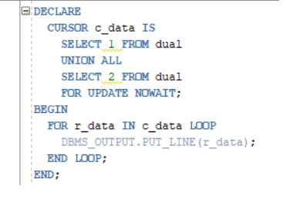

DECLARE

CURSOR c_data IS

SELECT 1 FROM dual

UNION ALL

SELECT 2 FROM dual

FOR UPDATE NOWAIT;

BEGIN

FOR r_data IN c_data LOOP

DBMS_OUTPUT. PUT_LINE (r_data);

END LOOP;

END;

A) It displays 1 and 2.

B) Raises an error because of the FOR UPDATE NOWAIT clause in the cursor declaration.

C) Raises an error because you cannot loop through a cursor that has a UNION ALL.

D) It only displays 1.

12). Which numbers will be displayed when this code runs?

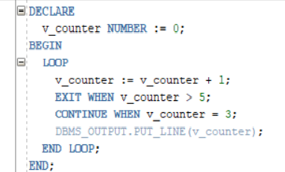

DECLARE

V_counter NUMBER := 0;

BEGIN

LOOP

V_counter := v counter + 1;

EXIT WHEN _counter > 5;

CONTINUE WHEN v_counter = 3;

DBMS_OUTPUI. PUT_LINE (v_counter);

END LOOP;

END;

A) 1, 2, 3, 4, 5

B) 1, 2, 4, 5

C) 1, 2, 3, 5

D) 1, 2, 4, 5, 6

13). What will this code produce?

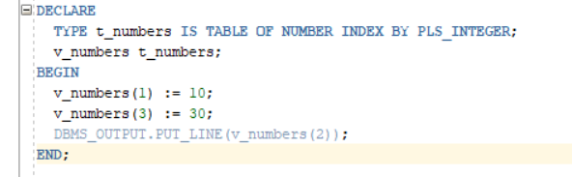

DECLARE

TYPE t_numbers IS TABLE OF NUMBER INDEX BY PLS_INTEGER;

v_numbers t_numbers;

BEGIN

V_numbers (1) := 10;

V_numbers (3) := 30;

DBMS_ OUTPUT. PUT_ LINE (v_numbers (2));

ЕND;

A) 10

B) NULL

C) An error stating the subscript is outside the allowed range.

D) 30

14). What does this PL/SQL block do?

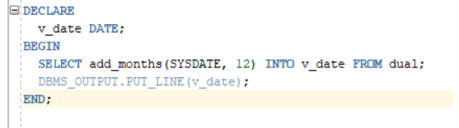

DECLARE

V_date DATE;

BEGIN

SELECT add_months (SYSDATE, 12) INTO v_date FROM dual;

DBMS_QUIPUI.PUT_LINE(v_date);

END;

A) Outputs the current system date.

B) Outputs the system date from 12 months ago.

C) Outputs the system date of 12 months in the future.

D) Raises an error due to an invalid date operation.

15). A PL/SQL anonymous block is trying to fetch the last name of an employee with EMPLOYEE_ID of 150 from the EMPLOYEES table. Which of the following statements will successfully fetch this value?

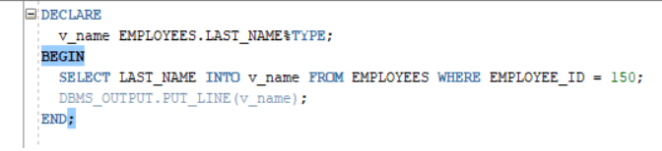

DECLARE

v_name EMPLOYEES. LAST _NAME%TYPE;

BEGIN

SELECT LAST_NAME INTO V _name FROM EMPLOYEES WHERE EMPLOYEE_ID =150;

DBMS_OUTPUT.PUT_LINE(v_name);

END;

A) This will successfully print the last name.

B) This will raise a NO_DATA_FOUND exception if no employee with EMPLOYEE_ID 150 exists.

C) This will raise a TOO_MANY_ROWS exception if there are duplicate rows.

D) Both B and C are possible outcomes.

16). What will be the output of the following PL/SQL block, given that the EMPLOYEES table in the HR schema has data?

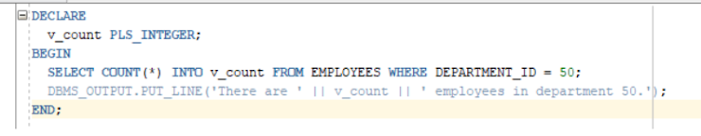

DECLARE

V_Count PLS_INTEGER;

SELECT COUNT (*) INTO V_Count FROM EMPLOYEES WHERE DEPARTMENT_ID = 50;

DBMS_OUTPUT.PUT_LINE(‘There are’ || v_count || ‘employees in department 50.’);

END;

A) An error because DEPARTMENT_ID does not exist.

B) An exact number of employees in department 50.

C) An error due to a missing semicolon after the DBMS_OUTPUT line.

D) The block will run without errors but will not produce any output.

17). The HR department wants to fetch the highest salary from the EMPLOYEES table but receives an error. What could be the potential mistake in the following block?

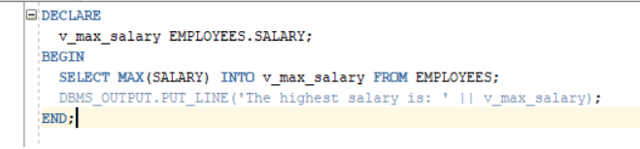

DECLARE

v _max_salary EMPLOYEES.SALARY;

BEGIN

SELECT MAX (SALARY) INTO V_max_salary FROM EMPLOYEES;

DBMS_OUTPUT.PUT_LINE ('The highest salary is: ' || v_max_salary);

END;

A) The DBMS_OUTPUT line is missing a semicolon.

B) The datatype declaration for v_max_salary is incorrect.

C) There is no mistake in the block.

D) The MAX function cannot be used with the INTO clause.

18). What will this code produce?

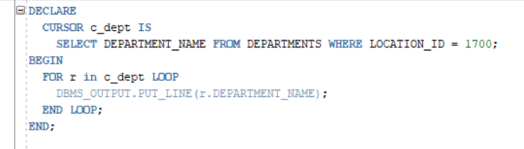

DECLARE

CURSOR c_dept IS

SELECT DEPARTMENT_NAME FROM DEPARTMENTS WHERE LOCATION_ID = 1700;

BEGIN

FOR r in c_dept LOOP

DBMS_OUTPUT.PUT_LINE (r.DEPARTMENT_NAME);

END LOOP;

END;

A) Names of all departments.

B) Names of departments located at LOCATION_ID 1700.

C) An error message because the cursor hasn't been opened.

D) An error message because the cursor hasn't been closed.

19). You want to find the total salary expenditure of the HR department. The following block has been written:

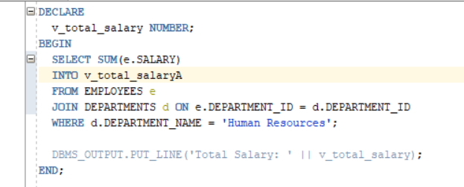

DECLARE

v_total_salary NUMBER;

BEGIN

SELECT SUM (e. SALARY)

INTO v_total salaryA

FROM EMPLOYEES e

JOIN DEPARTMENTS d ON e.DEPARTMENT_ID =d. DEPARTMENT_ID

WHERE d.DEPARTMENT_NAME = "Human Resources';

DBMS_OUTPUT. PUT_LINE ('Total Salary: ‘ || v_total_salary);

END;

A) Yes, it is correct.

B) No, there's an error in the join condition.

C) No, the DEPARTMENT_NAME column does not exist in the DEPARTMENTS table.

D) No, the SUM function cannot be used with the INTO clause.

20). What is an exception in PL/SQL?

a) A normal program flow

b) A predefined error condition

c) A user-defined variable

d) A database table

21). What is the purpose of the RAISE statement in PL/SQL?

a) To catch exceptions

b) To declare a variable

c) To handle errors

d) To raise a user-defined exception

22). What is a PL/SQL procedure?

a) A function that returns a value

b) A named block of code that performs an action

c) A data structure

d) A database table

23). Can PL/SQL procedures have parameters?

a) Yes, only input parameters

b) Yes, only output parameters

c) Yes, both input and output parameters

d) No, procedures cannot have parameters

24). How is a PL/SQL procedure called from within another PL/SQL block?

a) Using the CALL statement

b) Using the EXECUTE statement

c) Using the BEGIN statement

d) Using the name of the procedure

25). How is a PL/SQL function different from a procedure?

a) Functions cannot have parameters

b) Functions cannot return values

c) Functions must have an EXCEPTION section

d) Functions return a value

26). How do you call a PL/SQL function from within a SQL statement?

a) Using the CALL statement

b) Using the EXECUTE statement

c) Using the SELECT statement

d) Using the name of the function

27). What is a PL/SQL package?

a) A collection of procedures and functions

b) A single PL/SQL statement

c) A database table

d) A database trigger

28). What is the purpose of a PL/SQL package body?

a) To declare package variables

b) To define the implementation of package procedures and functions

c) To store data in a table

d) To handle exceptions

29). Can a PL/SQL package have private variables and procedures?

a) No, all variables and procedures in a package are public

b) Yes, but only variables can be private

c) Yes, both variables and procedures can be private

d) Yes, but only procedures can be private

30). How can you access a procedure defined in a PL/SQL package from outside the package?

a) By calling it directly

b) By using the PACKAGE keyword

c) By importing the package

d) By using the package name and procedure name

31). Which of the following is a feature of a PL/SQL procedure?

a) It always returns a value

b) It is used to perform calculations

c) It can have IN, OUT, and IN OUT parameters

d) It is used to define a database schema

32). What are the two parts of a PL/SQL package?

A) Specification and Body

B) Declaration and Definition

C) Begin and End

D) Public and Private

33). What is the output of the following PL/SQL block?

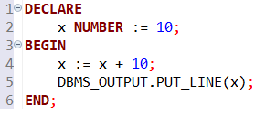

DECLARE

X NUMBER:=10;

DBMS_OUTPUT.PUT_LINE(x);

END;

A)10

B)20

C)Error

D)None of the above

34). Consider the following PL/SQL block. What will it output?

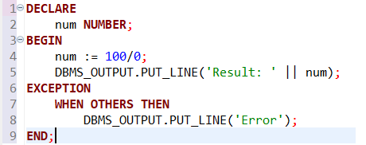

DECLARE

Num:=100/0;

DBMS_OUTPUT.PUT_LINE(‘Result:’ || num);

EXCEPTION

WHEN OTHERS THEN

DBMS_OUTPUT.PUT_LINE(‘Error’);

END;

A)Result: 0

B)Error

C)Result: 100

D)None

35). What is the output of the following PL/SQL block?

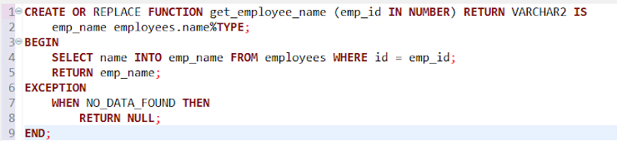

CREATE OR REPLACE FUNCTION get_employee_name (emp_id IN NUMBER) RETURN VARCHAR2 IS

emp_name employees.name%TYPE;

BEGIN

SELECT name INTO emp_name FROM employees WHERE id = emp_id;

RETURN emp_name;

EXCEPTION

WHEN NO_DATA_FOUND THEN

RETURN NULL;

END;

A)Returns employee name for given ID

B)Returns NULL if no employee found

C)Both A and B

D)None of the above

36). What is the output of the following PL/SQL block?

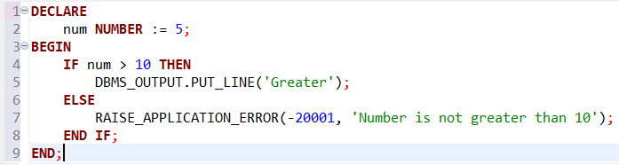

DECLARE

num NUMBER:= 5;

BEGIN

IF num > 10 THEN

DBMS_OUTPUT.PUT_LINE( 'Greater');

ELSE

RAISE_APPLICATION_ERROR(-20001, 'Number is not greater than 10');

END IF;

END;

A)Outputs 'Greater'

B)Raises an application error

C)Does nothing

D)Syntax error

37). What is the output of the following PL/SQL block?

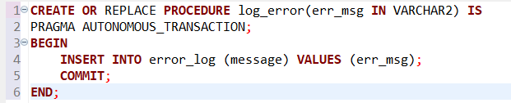

CREATE OR REPLACE PROCEDURE log_error(err_msg IN VARCHAR2) IS

PRAGMA AUTONOMOUS_TRANSACTION;

BEGIN

INSERT INTO error_log (message) VALUES (err_msg);

COMMIT;

END;

A)Logs an error message to a table

B)Rolls back on error

C)Syntax error

D)None of the above

38). What is the output of the following PL/SQL block?

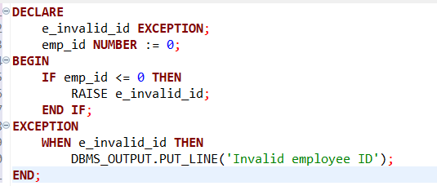

DECLARE

E_invalid_id EXCEPTION;

emp_id NUMBER := 0;

BEGIN

IF emp_id <= 0 THEN

RAISE e_invalid_id;

END IF;

EXCEPTION

WHEN e_invalid_id THEN

DBMS_OUTPUT.PUT_LINE('Invalid employee ID');

END;

A)prints 'Invalid employee ID'

B)Raises an unhandled exception

C)Does nothing

D)Syntax error